ATT_ How to Update the Customer’s Payment Method in BOOST?

In BOOST, Go to Customer Care Tab > Search for the User (thanks to the Email, Name, BAN, BTN, etc.) > Locate & Open the Customer’s Profile by clicking on the User’s Name/Email Address link.
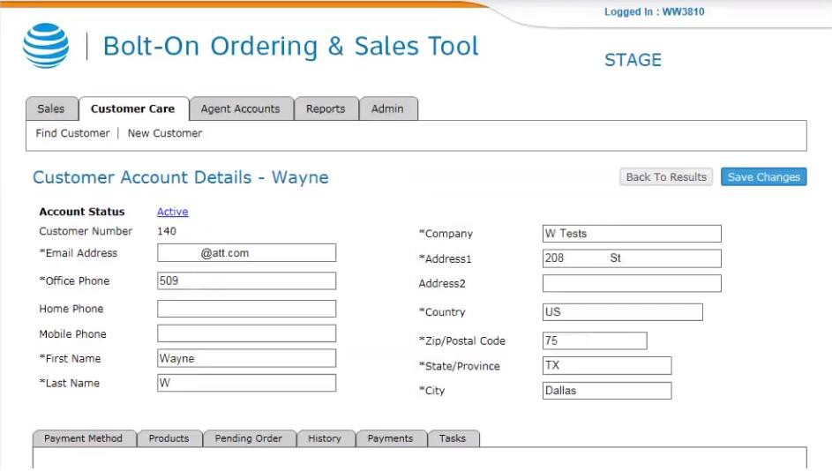

On the Customer’s Profile, Scroll down to the Payment Method section (Default tab) > Select the Payment Method to be used > Enter the required information on the new Payment Method > Click the Save Changes button.
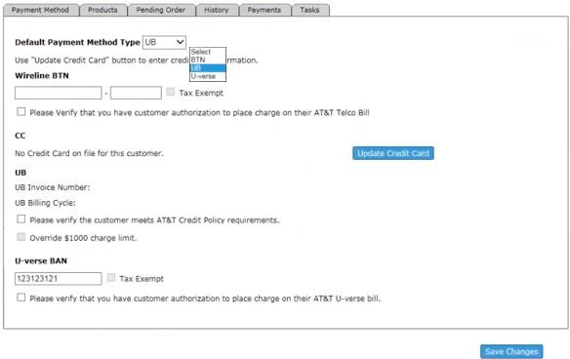

The Bill for the next billing cycle will be sent to the Customer using the new Payment
Method. Any unpaid bills will also be sent to the new biller for payment.

