ATT_ How to Create a New User in BOOST?

New Customers are normally created on the Record a Sale page at the same time as they place their first order. However, should you need to create a Customer who has not yet ordered any products:
On the Customer Care Tab > Click the New Customer Link > Enter the fields with the Customer's information (Required fields are marked with an asterisk) > Click the Create New Customer Button.
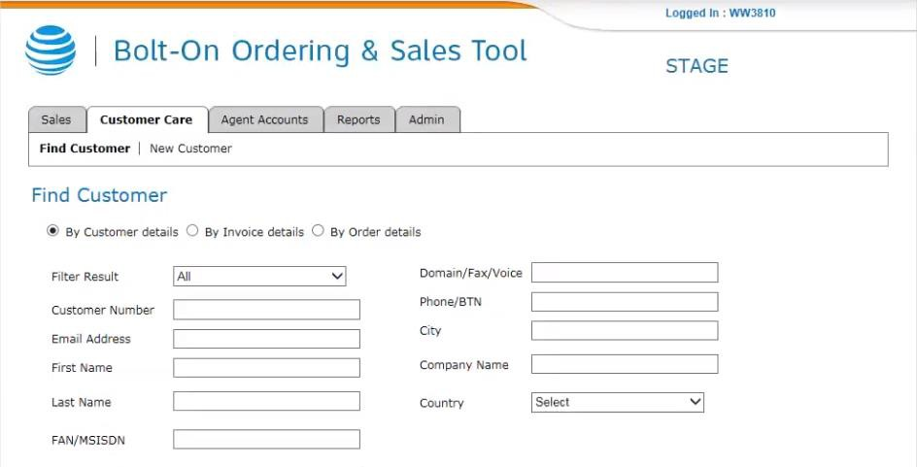

The New Customer is created and the Customer Account Details page is displayed with the message, 'New Customer Successfully Created'.

